Sri Lanka Institute of Information

Technology



Lab Submission

<Lab sheet No05>

**<IT24102671>**

**<RajapakshaR.G.A.S>**

B.Sc. (Hons) in Information Technology

**1.**





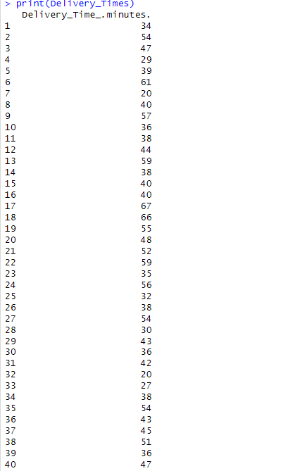

**2.**





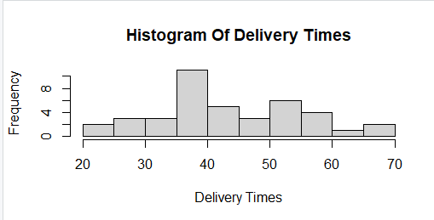

**3.**

